**Pizza Sales SQL Queries**

1. KPI’s
2. Total Revenue:

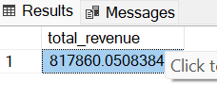

1. Average Order Value:

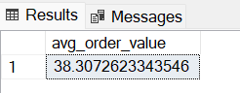

1. Total Pizza Ordered:

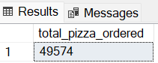

1. Total orders:

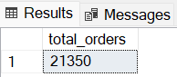

1. Average Pizza Per Order:

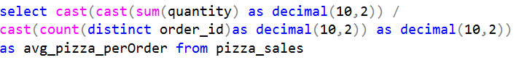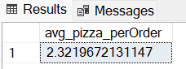

1. Questions Part 2:
2. Orders by week day:

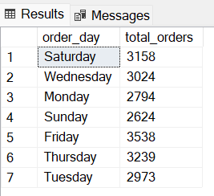

1. Order by months:

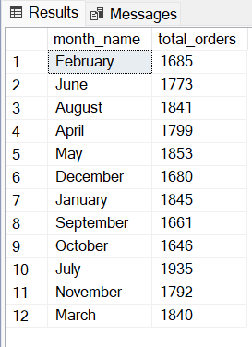

1. Percent of sales by pizza category:

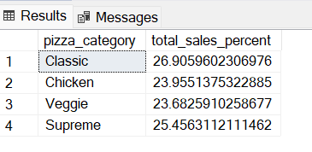

1. Sales by pizza size:

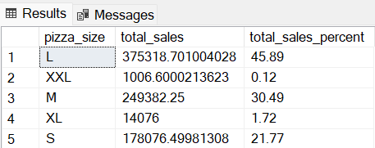

1. Top 5 pizza by total revenue:

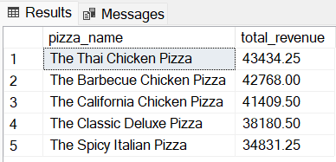

1. Bottom 5 pizzas by total revenue:

